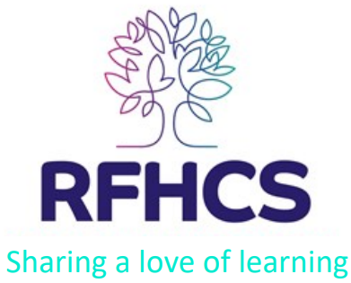
ROYAL FREE HOSPITAL CHILDREN’S SCHOOL
TERMS OF REFERENCE PASTORAL AND CURRICULUM COMMITTEE

Chair: Miriam Ashwell
Membership: Between 4 – 6 governors, including the Headteacher
Quorum: At least 3 governors, one of whom must be the Headteacher. There must not be a majority of governors who are also employees of the school
Meetings: The committee shall meet as required, but usually once a term. Two weeks’ notice of a meeting shall be given.
Terms of Reference:
The Pastoral and Curriculum Committee’s main roles are to
• Support the Headteacher in regularly reviewing the school aims and formulating a long-term strategic plan for the school;
• Assist the Headteacher in ensuring that the school provides safe, enjoyable and stimulating education for all its children appropriate to their particular medical, psychological and learning needs;
• Ensure the school meets all statutory requirements related to teaching and learning, safeguarding and pupil well-being;
• Contribute actively to the school’s self-evaluation in particular of areas which relate directly to teaching and learning, safeguarding and pupil well-being – e.g. quality of teaching; pupil progress; healthy schools etc.;
• Monitor the implementation of those aspects of the School Improvement Plan which relate to the above.
The committee will make recommendation on these areas for final decision by the Governing Body. Reporting to the Governing Body at each meeting of the Governing Body, a brief report shall be presented by the committee. These responsibilities will be reviewed annually in the Autumn Term meeting of the Governing Body.

Date reviewed: October 2024
Date of next review: September 2025
Date approved by the Governing Body: 17/10/2024

